Date access: 2020-03-09

<http://wjw.beijing.gov.cn/wjwh/ztzl/xxgzbd/gzbdyqtb/202001/t20200130_1621745.html>

From 20:00 on January 27th to 12:00 on the 28th, 11 new cases of pneumonia infected with new coronavirus were added to the city

Date: 2020-01-28 Source: Beijing Municipal Commission of Health

        From 20:00 of January 27th to 12:00 on the 28th, 11 new cases of pneumonia infected by the new coronavirus were added to the city, of which 5 had a history of contact in Hubei, and 7 were close contacts of previously confirmed cases. Level designated medical institutions for treatment

As of 12:00 on January 28, a total of 91 confirmed cases have been confirmed in this city. There are 2 cases in Dongcheng District, 8 cases in Xicheng District, 17 cases in Chaoyang District, 21 cases in Haidian District, 7 cases in Fengtai District, 2 cases in Shijingshan District, 7 cases in Tongzhou District, 2 cases in Shunyi District, 7 cases in Daxing District, and 7 cases in Changping District. There were 11 cases of foreigners coming to Beijing.

**1月27日20时至28日12时，本市新增11例新型冠状病毒感染的肺炎病例**

日期：2020-01-28 来源：北京市卫生健康委‍

        1月27日20时至28日12时，本市新增11例新型冠状病毒感染的肺炎病例，其中5例有湖北接触史，7例为此前确诊病例的密切接触者，均已送至市级定点医疗机构进行救治。

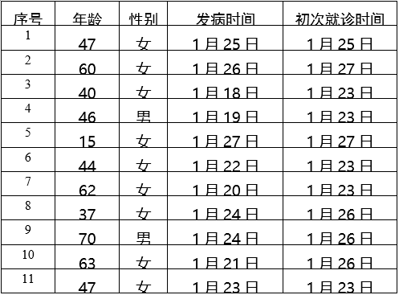

        截至1月28日12时，本市累计确诊病例91例。其中东城区2例、西城区8例、朝阳区17例、海淀区21例、丰台区7例、石景山区2例、通州区7例、顺义区2例、大兴区7例、昌平区7例，外地来京人员11例。